PO Box 161 Email: sanbornchamber@gmail.com
Sanborn, IA 51248 Website: www.sanbornchamber.com
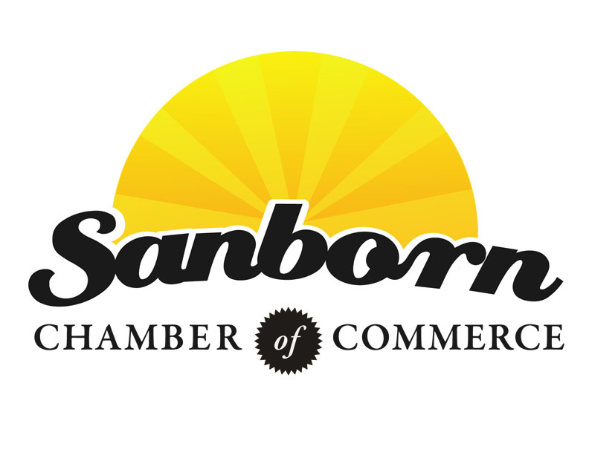

January 1, 2020
Dear Sanborn Community,
We would like to take the opportunity to thank our current Chamber members for their continued support of the Chamber. It is through your membership in the Sanborn Chamber of Commerce that the city of Sanborn and its surrounding areas continue to grow and thrive. We sincerely appreciate your participation in, and support of, the many events in 2019.
Your membership provides funds for the many benefits given to you as business members each year, including website listings, advertising opportunities, and business building opportunities. Your membership also provides the funds needed to host and promote the events people have come to expect and enjoy each year in Sanborn. Community events are an important part of a lively and growing city, so your participation as a member of the Sanborn Chamber of Commerce continues to provide such events for Sanborn.
We also want to remind you that you do not have to be a business owner to be a member of the Sanborn Chamber of Commerce. We welcome our community members to join us as Civic Members as you, too, will receive the same benefits that the business members do. You will also stay up to date on of the happenings within the Sanborn Chamber of Commerce.
We are always looking for new ways to promote growth and development in Sanborn that benefit the businesses and people of our community. We are inviting new businesses and organizations to join us as Chamber members to help us further support the Sanborn community.
The Annual Meeting is scheduled for Thursday, February 6, 2020 and is being held at the Vander Haag Yesterday’s Memories Museum. We are hosting the 3rd Annual Chili Cook-Off that will be open to all Sanborn Businesses and the public, the Annual Chamber Meeting will follow. We encourage you to mark your calendars and SAVE-THE-DATE!
Please feel free to contact the Chamber with any questions or concerns that you may have. If at this time you are not able to become a member but would like to show your support through other means or would like to make a donation, please contact any one of the Chamber Board of Directors.
On behalf of the Sanborn Chamber of Commerce we hope you had many blessings this Holiday Season and looking forward to a prosperous New Year!

Sanborn Chamber of Commerce

Sanborn Welcome Bags
We would like to continue giving Chamber members another great advertising opportunity! Once again we will be collecting any promotional items that you may have and would like to disperse! We will be placing the items in our “Welcome Bags” which will be given to ALL NEW residents and businesses in Sanborn.
Some examples would be:
business cards
flyers with hours, etc.
coupons
notepads
pens
or ANY other promotional items your business may have!
We would like to be able to represent ALL of our Chamber Businesses so that anyone new to the community will be able to know what is available to them in Sanborn!

Please bring items to Brian Visser at Iowa State Bank. We ask that we have approximately 50 of your item so that we can make the bags ahead of time. You may also bring your items along to the Annual Meeting.

Remember, this is a great way to get your business out there!
2020 Sanborn Chamber of Commerce

Membership Investment & Ad Campaign Invoice
Please complete this form and mail it or take it to the Annual Meeting with your check payable to:
Sanborn Chamber of Commerce, PO Box 161, Sanborn, IA 51248

2020 Dues for Membership & Ad Campaign are due on/before February 1, 2020.
Firm/Organization: __________________________________________________________________________________
Contact Person: _____________________________________________________________________________________
Mailing Address: ____________________________________________________________________________________
Physical Location (if different from mailing address): _______________________________________________________
Phone/Cell: ____________________________________ Website: ____________________________________________
E-mail Address: (Routine Correspondence Method) _________________________________________________________

Honorary Membership for ALL Churches. Open to donations, but not required. $ Waived
Basic Membership: (For Schools, Library, and Civic Members) Suggested Donation $75 = $__________
Business Membership Tiers (please check one):
- Tier 1 Membership (1 employee) ……………………………………………………………………………………. $100.00
- Tier 2 Membership (Between 2 and 5 employees) ……………….…………………………………………. $125.00
- Tier 3 Membership (Between 6 and 15 employees) …………………………………………………..……. $185.00
- Tier 4 Membership (16 or more employees) …………….…………………………………………………….. $250.00
Grand Total Business Membership (Maximum of $250) Total: $__________

Donation Amount
Please contact a Chamber Board Member to how your donations help Sanborn. $
**Please consider an additional donation to our Chamber of Commerce for expenses such as Railroad Days Fireworks and other events to offset the Chamber’s costs so we can continue offering these FREE to our community and visitors. Please fill the amount and include it in your payment. You may also make donations throughout the year if you choose.

Total Amount Enclosed $

YOUR INVOLVEMENT WITH THE SANBORN CHAMBER OF COMMERCE IS NEEDED!

It is because of continued support and involvement in the community that Sanborn is able to offer fun and entertaining events throughout the year. Without the volunteers, time, talent and financial support, events like Railroad Days and Hometown Christmas would not be successful.

Whether you choose to be a Sanborn Chamber of Commerce member or not, your involvement is sincerely appreciated.

Would you like to be involved (planning/organizing/volunteering) with any of the activities put together by the Chamber (please circle one)?:

YES NO MAYBE

Would you like to learn more about being a member of the Chamber Board (please circle one)?:

- YES. Here is my contact information:

- NO

Do you have ideas for events and activities for Sanborn (please check one and tell us more)?:

- YES. Here is more information:

- NO

Would you like to financially support the activities put together by the Chamber (please check one and fill out more information where needed)?:
- YES, I have included a donation in the amount of:
  - $50
  - $100
  - $250
  - $500
  - $750
  - $1,000
  - Other: $_________
- NO, I am not interested at this time.
- MAYBE, please have someone contact me with more information:
Name: __________________________________________
Phone: _________________________________________
Email: __________________________________________

