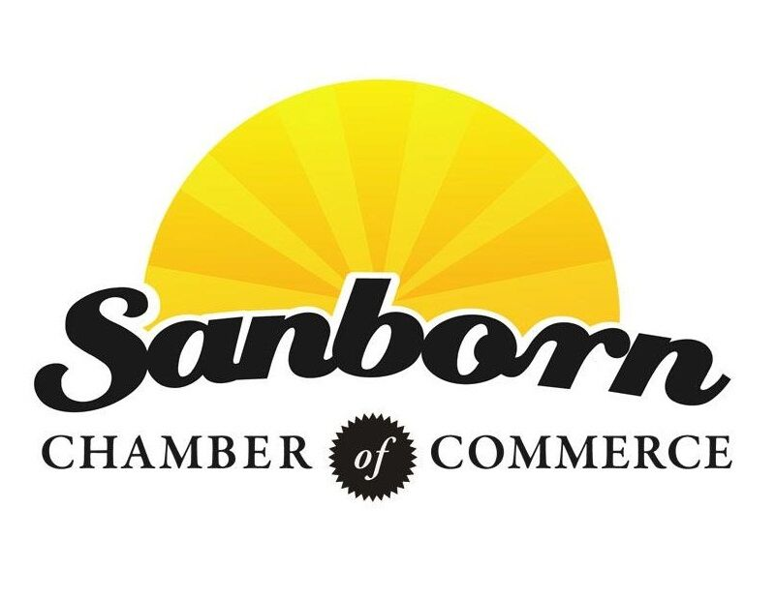
SANBORN RAILROAD DAYS PARADE
JULY 24, 2021

Parade Time: 10:30am
Line-up Time: 9:30-10:15am
Registration Location: Sanborn Christian Reformed Church
208 N. Western Street, Sanborn IA
**Recognition will be awarded for excellence**

If you have questions, please contact Jamie:
Please visit www.sanbornchamber.com for the complete event schedule and details.

Remember to “Like” the Sanborn Chamber of Commerce and the Sanborn Railroad Days on Facebook!

Work: 712-729-3691
Home: 712-729-5371
Fax: 712-729-5648
Email: jamie@elgersmaagency.com

Return this form by Friday, July 16, 2021 to:
Sanborn Chamber of Commerce
P.O. Box 161
Sanborn, IA 51248
OR Email: jamie@elgersmaagency.com

Detach here and return lower portion of this form along with a completed and signed Waiver of Liability.
---------------------------------------------------------------------------------------------------------------------------------------
Please type or print clearly. Announcers will use this information during the Parade.
Type of Entry (float, car, tractor, etc.): ____________________________________________________
Sponsoring Organization: ______________________________________________________________
Name of Contact Person: ______________________________________________________________
Telephone: _________________________________________________________________________
Address: ___________________________________________________________________________
E-mail Address: ______________________________________________________________________
Additional Information for announcers (please include names of personnel on entry):
____________________________________________________________________________________________________________________________________________________________________________________________________________________________________________________________________________________________________________________________________________

